**Introduction**

As number of Covid-19 positive cases are increasing exponentially in last few weeks, many of senior/retired citizens are reviewing option of relocating to their hometown or safest town near to their hometown in India. Our goal is to provide them with the data / report, that will help them decide right city/town they can relocate to.

Given the current pandemic situation, **we are required identify safest cities/towns across states of India that are safe to live/relocate for retired people/senior citizens.** Safe cities/towns are identified based on number of covid-19 cases in the respective state, per capita income and facilities available like - Parks, Restaurants, hotels, entertainment etc.,

Cities/towns are shortlisted based on the below criteria

* Number of Covid-19 positive cases should be less than 50,000
* Cities/towns from the states where Covid-19 positive cases are more than 50,000 are excluded.

Identified similar cities/towns are grouped in to 5 clusters for senior citizens to decide best city/town for her/him to live.

**Data Source**

In order to meet above expectation, we need a data source that gives information on numbers Covid-19 positive cases reported in each of the sates of India. this data was downloaded from on 27th of July.

1. Covid-19 cases reported on daily basis from 1 Apr 2020 till end 27 Jul 2020 downloaded from Kaggle.

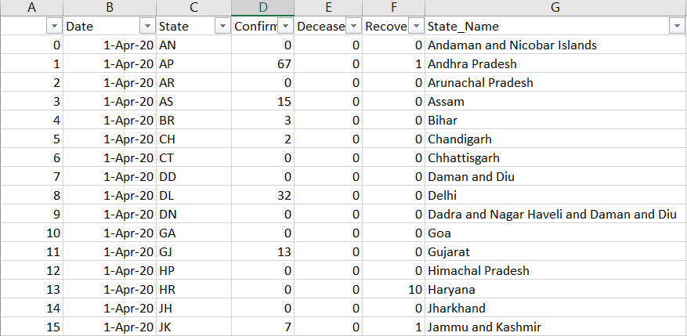

*Number of recovered cases are not considered as these were very small compared to number of cases reported

1. Per capita income of each state is extracted form Wikipedia

<https://en.wikipedia.org/wiki/List_of_Indian_states_and_union_territories_by_GDP_per_capita>

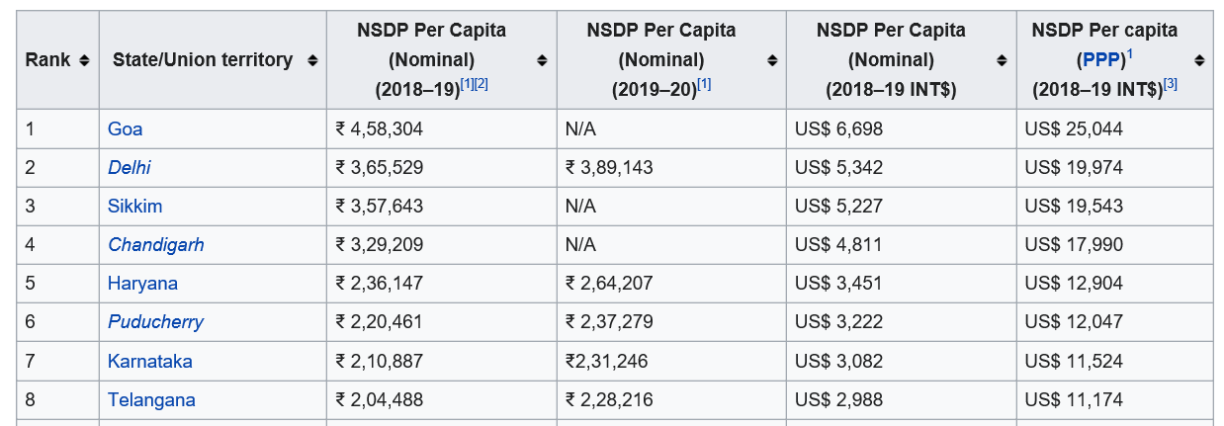

*Per capita income in FY19-20 are considered to give an idea on kind of living conditions that can be expected in a city/town within the given state.

1. Indian cities geo location information downloaded from Kaggle

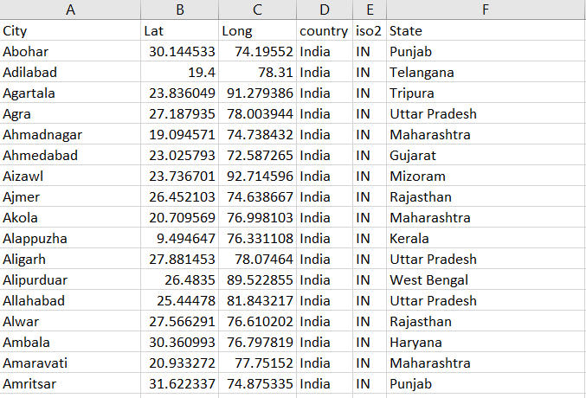

As per the requirement, first States with more than 50k Covid-19 positive cases needs to be excluded. The cases reported are grouped by state.

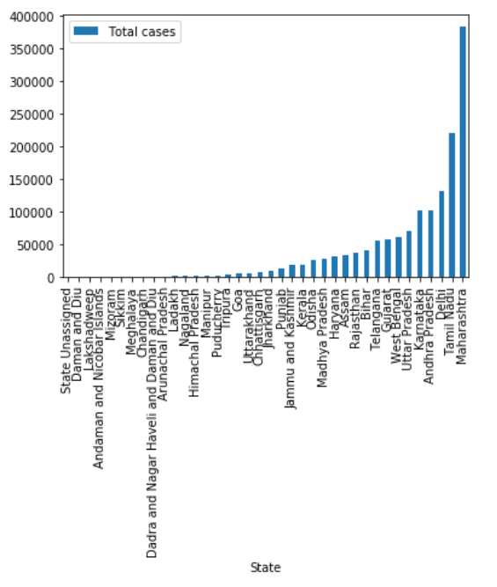

**Top 10 states with highest number of Covid-19 cases are identified**

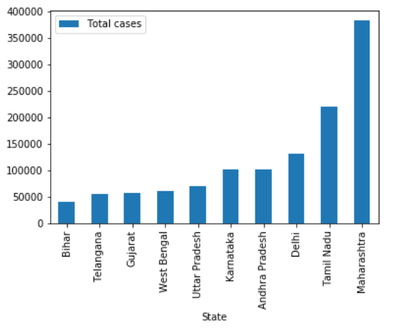

The states with more than 50k cases are excluded from the data frame. Then all the 3 data sources combined to get a single view of city, latitude, longitude, state, number of cases reported, per capita income etc.

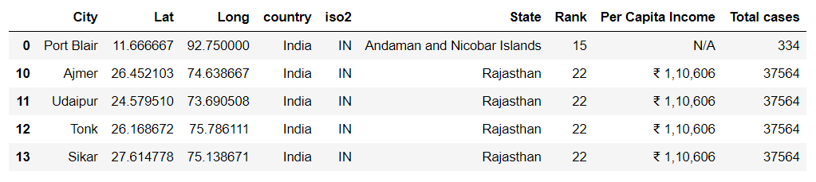

Use Foursquare API to get facilities/venue details of each Neighborhood/City

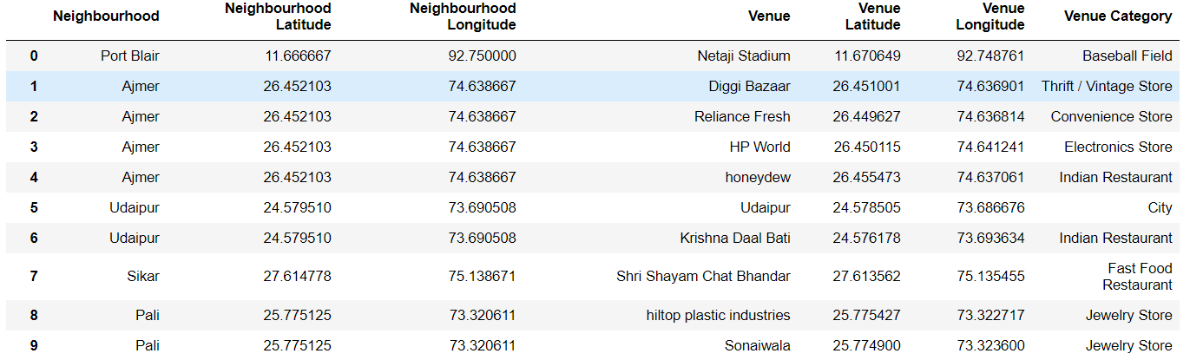

Get the data to the right format so it becomes easy to analyze.

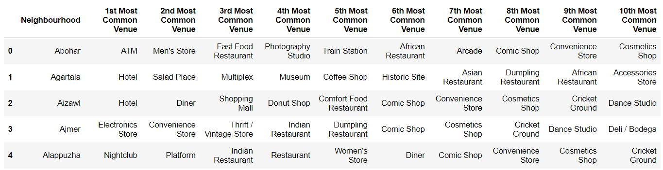

Cluster the data and plot the map.

The map shows cities/towns that are safe to relocate. However the a citizen can select a cluster (our of 5 denoted by 5 different color on the chart) based in his/her preferences/interests.

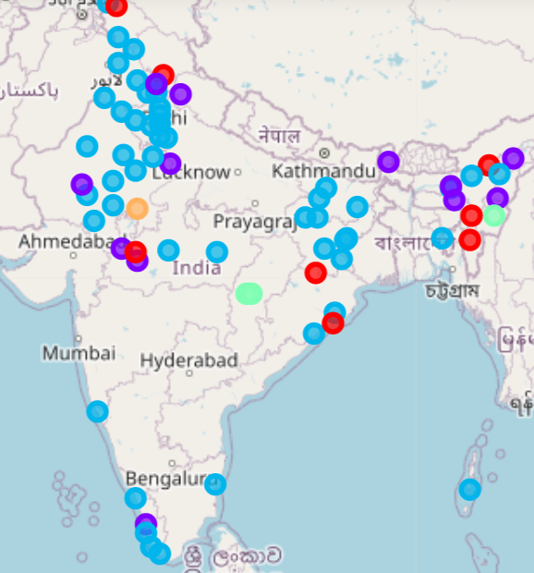

There are 73 cities/towns in the states which have less than 50k positive Covid -19 cases reported. These 73 cities have been divided into 5 clusters based on the venues/amenities.

**Cluster 0, 3 and 4 – are quiet cities/towns with minimum number of Hotels and Restaurants and shopping venues.**

**Cluster 1 – moderate in terms of shopping venues in addition to hotel and restaurants**

**Cluster 2 - is known for variety of shopping venues in addition to multi cuisine hotel and restaurants**

Based on their taste and requirement senior citizens can select one of the above cluster cities for relocation.